Athletics Events Held on Temporary Facilities
Survey Form 2020
(To be sent together with the Application Form)

GENERAL
This is generally completed by the company conducting the survey. The following key items must be provided:
- identification of the surveyor
- identification of the facility and event sites surveyed, including a plan showing field event layouts
- facility measurements on diagram provided – to note that:
  - distances longer than 20m are to be measured by electro optical instruments
  - angles are to be measured by theodolite
- details on the measurement instrument used including:
  - manufacturer and model
  - serial number
  - current (no older than 12 months) Certificate of Instrument Accuracy (mentioning the instrument serial number) that can be traced back to national and international standards of measurement (issued by an authorised service centre or laboratory)

To be noted that, when a competition is held over more than one day, the survey should be made on the day of the first event. In either case, if the surveyor can be satisfied that there will be no movement or alteration to the facilities being surveyed, the survey may be completed up to two days prior to the day of the first event.

It is not for the surveyor or others to determine whether dispensations might be provided for any non-conformity with the Rules or the stipulations of the Track and Field Facilities Manual. These are matters for World Athletics alone to determine.

All the information required in this form must be determined by the surveyor and he should not rely on any other measurement work that may have been done by others.

SURVEYOR
Company
Name
Address
Telephone
Email
Date of Survey
Weather conditions and temperature
Instrument | Theodolite: |  | No.:
 | Distance Meter: |  | No.:

FACILITY
Name
Address
Event Site(s) surveyed
EVENT SITE – MEASUREMENTS HIGH JUMP

Rule Requirement
The runway | The minimum width of the runway is 16m. The minimum length of the runway is 15m, if possible 25m. (Rule 27.3) |  | m
 | Does this length include part of the track? |  | Y N
The take-off area | The take-off area complies with Rule 27.5 as it is level or the inclination complies with Rule 27.4. |  | Y N
Inclination | The maximum overall inclination in the last 15m of the runway and take-off area is less than 1:167 (0.6%) in the direction of the centre of the crossbar (Rule 27.4) |  | Y N
Runway surface
Product name:
Product manufacturer:
Absolute thickness: |  | mm
World Athletics Product Certificate Number*:
* The current list of synthetic surfaces with Product Certificates is available under Certification System here: https://www.worldathletics.org/about-iaaf/documents/technical-information

EVENT SITE - SPOT LEVELS

Use the diagram to provide the required spot levels at the centre of the take-off and at 15m from the centre of each High Jump take-off.

It is essential that reduced levels (not grades) be provided on each of the runways.

The sign convention used by World Athletics for inclinations is that an upward inclination in the direction of running is positive.

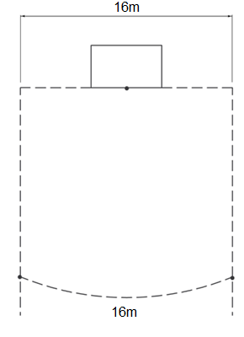

Name and City of Facility:
Site identification:

Provide runway radial levels at the centre of the take offs (0.000m) and 15m from the centre of each High Jump take off.
SURVEYOR’S CONCLUSIONS

The competition area was checked regarding layout, inclination and dimensional accuracy.

I hereby certify that all measurements and information shown in this report are accurate and are the result of a well-conducted survey.

Considering the attached measurements made during the inspection of the facility, I recommend that the facility be accepted to be in compliance with World Athletics requirements.

YES NO

If the answer is NO please state below the reason(s) why the facility does not comply under World Athletics Rules.

Date:
Surveyor’s Name:
Signature:

