Athletics Events Held on Temporary Facilities
Survey Form 2020
(To be sent together with the Application Form)

GENERAL
This is generally completed by the company conducting the survey. The following key items must be provided:
- identification of the surveyor
- identification of the facility and event sites surveyed, including a plan showing field event layouts
- facility measurements on diagram provided – to note that:
  - distances longer than 20m are to be measured by electro optical instruments
  - angles are to be measured by theodolite
- details on the measurement instrument used including:
  - manufacturer and model
  - serial number
  - current (no older than 12 months) Certificate of Instrument Accuracy (mentioning the instrument serial number) that can be traced back to national and international standards of measurement (issued by an authorised service centre or laboratory)

To be noted that, when a competition is held over more than one day, the survey should be made on the day of the first event. In either case, if the surveyor can be satisfied that there will be no movement or alteration to the facilities being surveyed, the survey may be completed up to two days prior to the day of the first event.

It is not for the surveyor or others to determine whether dispensations might be provided for any non-conformity with the Rules or the stipulations of the Track and Field Facilities Manual. These are matters for World Athletics alone to determine.

All the information required in this form must be determined by the surveyor and he should not rely on any other measurement work that may have been done by others.

SURVEYOR
Company
Name
Address
Telephone
Email
Date of Survey
Weather conditions and temperature
Instrument | Theodolite: |  | No.:
 | Distance Meter: |  | No.:

FACILITY
Name
Address
Event Site(s) surveyed
EVENT SITE – MEASUREMENTS SHOT PUT

IAAF Rule Requirement
The Shot Circle | The material of the circle is in accordance with the Rule. |  |  | Y N
 | The top of the circle is flush with the ground outside. (Rule 32.5) |  |  | Y N
 | White lines are drawn from the top of the metal rim. The construction is in accordance with the Rule: min. 0.75m long, 50mm wide (Rule 32.7) |  |  | Y N
 | The interior of the circle is constructed of:
 | The surface is level and lower than the upper edge of the rim of the circle. |  |  | Y N
 | The rim is min. 6mm thick and painted white. |  |  | Y N
 | The circle has an inside diameter of:  min. 2.130m  max. 2.140m  (Rule 32.6)  The circle has a depth of:  min. 14mm  max. 26mm  (Rule 32.5) | Diameter 1 | Length | m
 |  |  | Circle depth | mm
 |  |  | Circle depth | mm
 |  | Diameter 2 | Length | m
 |  |  | Circle depth | mm
 |  |  | Circle depth | mm
 |  | Diameter 3 | Length | m
 |  |  | Circle depth | mm
 |  |  | Circle depth | mm
 |  | Diameter 4 | Length | m
 |  |  | Circle depth | mm
 |  |  | Circle depth | mm
 |  | Circle depth at centre |  | mm
The landing sector | The landing sector consist of: (Rule 32.10)
 | The maximum overall downward inclination of the landing sector in the putting direction does not exceed 1:1000. (Rule 32.11) |  |  | Y N

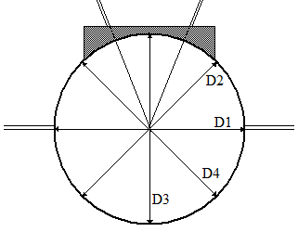

EVENT SITE - SPOT LEVELS

Use the diagram to provide levels at the circle and for the landing area at the 10m, 15m, 20m and 25m arcs at the two sector extremities and the centreline.

It is essential that reduced levels (centre of circle = 0.000m) are provided in metres to three decimal places: 0.000m.

The sign convention used by World Athletics for inclinations is that an upward inclination in the direction of throwing is positive. At any radius, the lowest level is compared with the throwing circle level to determine the inclination.

The stop board must be checked before a competition.

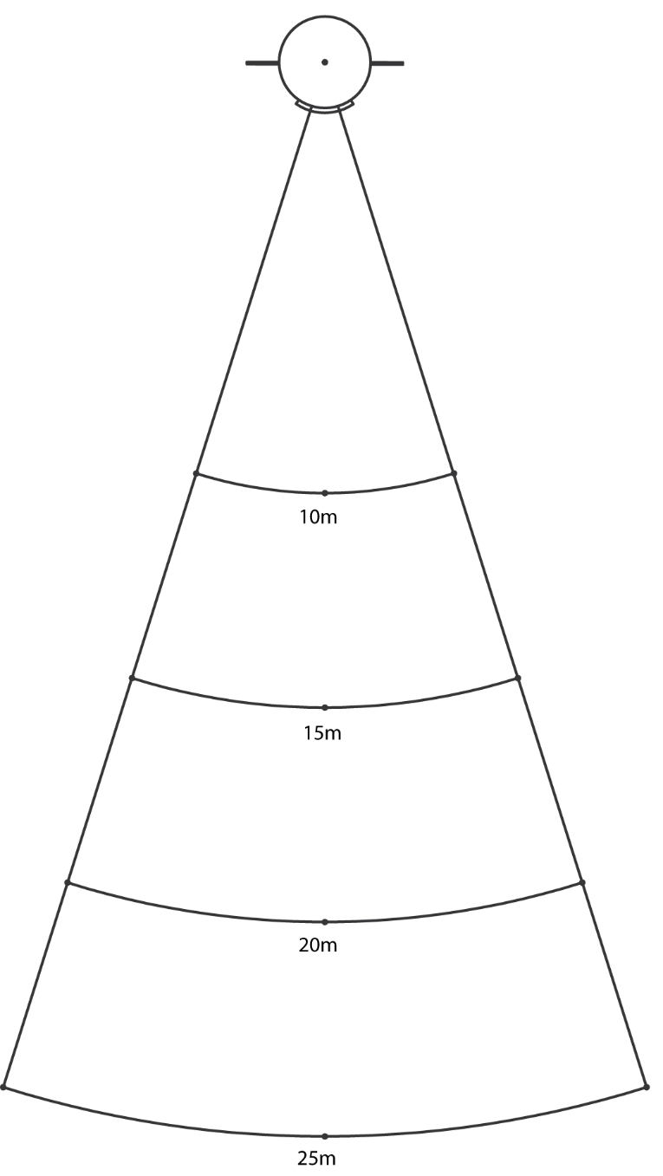

SURVEYOR’S CONCLUSIONS

The competition area was checked regarding layout, inclination and dimensional accuracy.

I hereby certify that all measurements and information shown in this report are accurate and are the result of a well-conducted survey.

Considering the attached measurements made during the inspection of the facility, I recommend that the facility be accepted to be in compliance with World Athletics requirements.

YES NO

If the answer is NO please state below the reason(s) why the facility does not comply under World Athletics Rules.

Date:
Surveyor’s Name:
Signature:

